Textiles designs – ‘Cretonnes’ by Adolphe Valette

Valette’s legacy is mainly seen today in his large seminal impressionist paintings of Manchester created in the early 1900s, with many exhibited at the Manchester Art Gallery.
However, in order to make a living Valette, like other artists, was compelled to earn money through other means: he was an art teacher at the Manchester School of Art (where he taught L.S. Lowry for more than a decade), a portrait painter for the well-to-do Mancunian society and he also supplemented his income with numerous commercial activities: private decorations for individual homes; church decorations; commercial poster designs and also textile designs.
In his initial training in France, as an art student at the Ecole des Beaux-Arts de St-Etienne, Valette attended the ‘Classe de la Fleur’ (class for the drawing of flowers). At the end of the 19th century, in the region of Saint-Etienne and Lyon, young aspiring artists learned to draw flowers with the aim of designing for fabrics or wallpapers. There was a need for skilled draughtsmen who could draw any motif requested by the ‘fabriques’ (textile factories) to suit the needs of the customers. These draughtsmen were the offshoot of professional painting and a skill much sought-after in Valette’s time when computer aided design obviously did not exist.

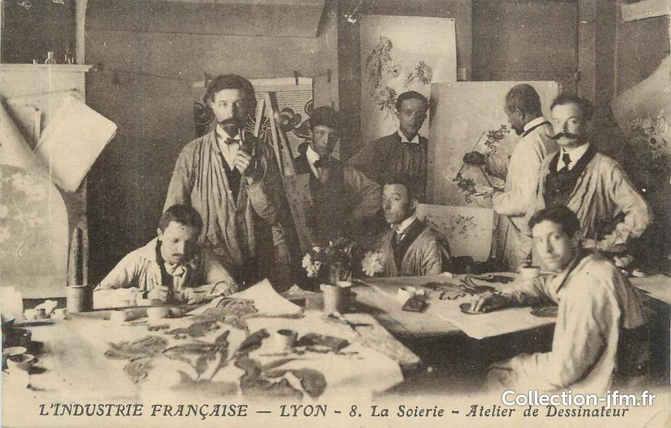

The photograph of the studio in Lyon illustrates eloquently the work of the draughtsmen on drawing boards. Floral designs can be seen being created on the large sheets of paper.

The ‘fabriques’ needed hundreds of men – women were allowed only later, in the second part of the 20th century – to design all sorts of attractive motifs. Some of these men were in full-time employment, some like Valette were freelance.

The activity of textile design was quite important for Valette. We can assume that he started while he was still living in Manchester. Indeed, when Valette moved, in 1928, back to the Beaujolais in France, his wife Andrée made, as people still do today, a ‘removals list of items’ to be transported. The removals company was Harrods and we have had the serendipity to find in archives, Valette’s removals list of items where there are several mentions of the name ‘cretonnes’ (which is the name in French of these textile designs) and the mention of a drawing board and of large sheets of paper specifically used for ‘cretonnes’, which indicates the importance of this activity for Valette.

These designs are not signed or dated, which is usual for that type of work. The numbers found on some sheets actually refer to pattern numbers, not to a date.
There are many hand-written notes by Valette on these designs, related to the colours or technical details regarding the patterns. The notes are in French, which indicate he would be working for a French company.

The motifs on the textile designs are varied and in keeping with the style in vogue at the time used for rich interiors. The level of detail is stunning. The style is elegant, intricate and harmonious at the same time. The motifs are mostly flowers and sometimes birds-and-flowers, as was the tradition. The variety of colours used is wide and researched.

Quite a few of these designs have East Asian qualities. Initially Valette aimed to go to Japan to study the influence of Japanese art and prints on Impressionism. One of his teachers in Bordeaux was the Japanese Consul. Asian, Chinese and Japanese designs are part of what was at the time a new modern global trade, which blossomed with world exhibitions.

From 1905, when Valette was working for the printing company Norbury, Natzio & Co on Princess Street just opposite the Manchester Art Gallery, he was creating designs for stock tickets destined for the Far East.

We cannot totally exclude that some of these drawings were made for wallpapers, however in one small drawing there is a direct written link to ‘toile de Tours’, which was another well-known centre for the production of silk fabrics in France. So, in our view and in accordance with what has been explained by the previous owners of these designs, we believe they were meant for soft furnishings and fabric ornamentation. These drawings have been kept for decades in the same family, the descendants of Mademoiselle Denavit, one of Valette’s friends in Blacé in the Beaujolais where the artist had a house. Later, they became part of an English collection.

Some designs coming from this portfolio were exhibited during the exhibition Adolphe Valette, a Pioneer of Impressionism in Manchester which took place at The Lowry, in 2011-12. They are mentioned in the book ‘Adolphe Valette & L.S. Lowry’ (published in 2020): in the foreword written by Claire Stewart, Curator of the L.S. Lowry Collection on page 9 and also in the book itself on page 16.

It is a great moment that these drawings, these ‘cretonnes’, can be admired by members of the general public revealing a much-forgotten aspect of Valette’s talent, and that these splendid floral designs can give a touch of French brightness and lustre to the homes of collectors in Manchester and its region, where they were initially conceived.

Cécilia Lyon

